DAFTAR ISI

DAFTAR ISI 1
A. IDENTITAS 2
B. HASIL PRAKTIKUM/ TUGAS 2
1. RINGKASAN MODUL 3
2. PRAKTIKUM 3
a. Demo 1 3
b. Demo 2 8
c. Demo 3 13
d. Demo 4 18
e. Hitung Mundur Worker 22
f. Demo 5 24
3. LATIHAN 30
a. Task Worker 30
b. Demo 6 32
C. PENGALAMAN PEMBELAJARAN 38

IDENTITAS
NIM : 2403001
Nama Lengkap : Siti Sa’adah
Kelas : D3 TI 2A
Program Studi : D3 TEKNIK INFORMATIKA
Jurusan : TEKNIK INFORMATIKA

HASIL PRAKTIKUM/ TUGAS
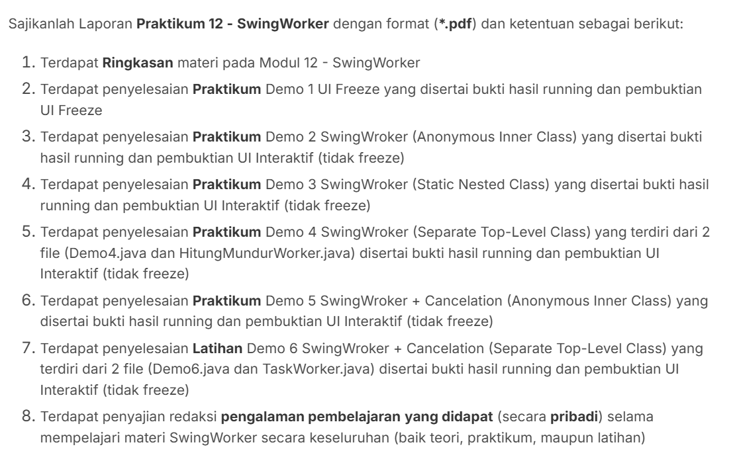

RINGKASAN MODUL
Pada materi kali ini menbahas mengenai SWING WORKER. Dimana di dalam nya menjelaskan mengenai Corcurency yang di implemntasikan dengan berbagai cara;
diantaranya :
- Multithreading
- Multiprocessing
- Single-threaded concurrency

PRAKTIKUM

Demo 1
- Kode Program
package Praktikum;
import java.awt.*;
import java.awt.event.ActionEvent;

import javax.swing.*;

import net.miginfocom.swing.MigLayout;

public class Demo1 extends JFrame {

private JPanel panelUtama;
private JButton buttonMulaiTask;
private JLabel labelStatus;
private JTextArea textAreaHasil;

public Demo1() {
initializeUI();
setupEventHandlers();
}

private void initializeUI() {
setTitle("Demo 1: UI Freeze");
setDefaultCloseOperation(JFrame.EXIT_ON_CLOSE);
setPreferredSize(new Dimension(560, 420));

panelUtama = new JPanel(
new MigLayout(
"fill, wrap 1, insets 20",
"[grow]"
)
);

buttonMulaiTask = new JButton("Mulai Task (8 detik)");
buttonMulaiTask.setFont(new Font("Inter", Font.BOLD, 18));
panelUtama.add(buttonMulaiTask, "growx, h 20%");

labelStatus = new JLabel("Status: Siap", JLabel.CENTER);
labelStatus.setFont(new Font("Inter", Font.PLAIN, 22));
labelStatus.setForeground(new Color(0, 102, 204));
panelUtama.add(labelStatus, "growx, h 20%");

textAreaHasil = new JTextArea(10, 50);
textAreaHasil.setEditable(false);
textAreaHasil.setFont(new Font("Consolas", Font.PLAIN, 15));
JScrollPane scroll = new JScrollPane(textAreaHasil);
panelUtama.add(scroll, "growx, h 60%");

add(panelUtama);
pack();
setLocationRelativeTo(null);
}

private void setupEventHandlers() {
buttonMulaiTask.addActionListener((ActionEvent e) -> {
buttonMulaiTask.setEnabled(false);
labelStatus.setText("Status: Sedang bekerja");
textAreaHasil.setText("Mengerjakan Background Task (8 detik)\n");

for (int i = 8; i >= 0; i--) {
final int seconds = i;
SwingUtilities.invokeLater(() -> {
textAreaHasil.append("Hitung mundur: " + seconds + "\n");
textAreaHasil.setCaretPosition(textAreaHasil.getDocument().getLength());
labelStatus.setText("Sisa " + seconds + " detik");
});

try {
Thread.sleep(1000);
} catch (InterruptedException ex) {
Thread.currentThread().interrupt();
}
}
textAreaHasil.append("Background Task selesai\n");
labelStatus.setText("Status: Selesai");
JOptionPane.showMessageDialog(
this,
"Background Task Selesai",
"Informasi",
JOptionPane.INFORMATION_MESSAGE
);
buttonMulaiTask.setEnabled(true);
});
}

public static void main(String[] args) {
SwingUtilities.invokeLater(() -> {
try {
UIManager.setLookAndFeel(UIManager.getSystemLookAndFeelClassName());
} catch (Exception e) { }

new Demo1().setVisible(true);

} );
}
}

- Hasil Run
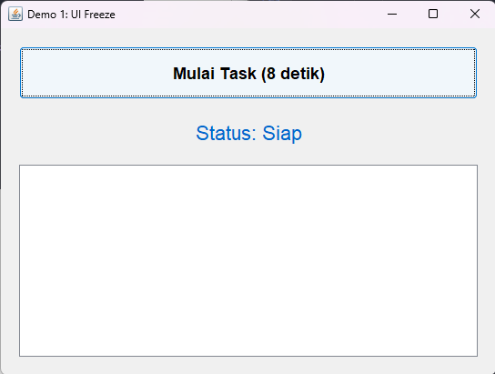

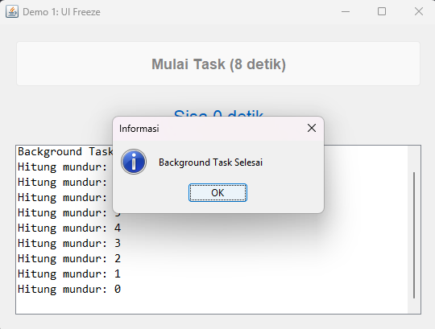

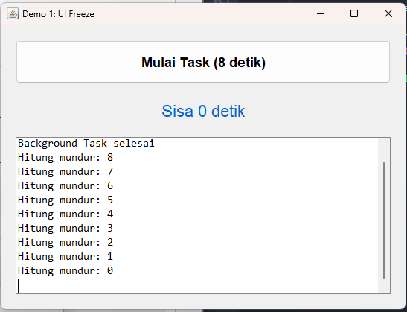

Demo 2
- Kode Program
package Praktikum;
import java.awt.Color;
import java.awt.Dimension;
import java.awt.Font;
import java.util.List;

import javax.swing.JButton;
import javax.swing.JFrame;
import javax.swing.JLabel;
import javax.swing.JOptionPane;
import javax.swing.JPanel;
import javax.swing.JScrollPane;
import javax.swing.JTextArea;
import javax.swing.SwingUtilities;
import javax.swing.SwingWorker;
import javax.swing.UIManager;

import net.miginfocom.swing.MigLayout;

public class Demo2 extends JFrame {

private JPanel panelUtama;
private JButton buttonMulaiTask;
private JLabel labelStatus;
private JTextArea textAreaHasil;
private SwingWorker<String, Integer> worker;

public Demo2() {
initializeUI();
setupEventHandlers();
}

private void initializeUI() {
setTitle("Demo 2: SwingWorker (Anonymous Inner Class)");
setDefaultCloseOperation(JFrame.EXIT_ON_CLOSE);
setPreferredSize(new Dimension(600, 450));

panelUtama = new JPanel(
new MigLayout("fill, wrap 1, insets 20")
);

buttonMulaiTask = new JButton("Mulai Task (8 detik)");
buttonMulaiTask.setFont(new Font("Inter", Font.BOLD, 18));
panelUtama.add(buttonMulaiTask, "growx, h 20%");

labelStatus = new JLabel("Status: Siap", JLabel.CENTER);
labelStatus.setFont(new Font("Inter", Font.PLAIN, 22));
labelStatus.setForeground(new Color(0, 128, 0));
panelUtama.add(labelStatus, "growx, h 20%");

textAreaHasil = new JTextArea();
textAreaHasil.setEditable(false);
textAreaHasil.setFont(new Font("Consolas", Font.PLAIN, 15));
JScrollPane scroll = new JScrollPane(textAreaHasil);
panelUtama.add(scroll, "growx, h 60%");

add(panelUtama);
pack();
setLocationRelativeTo(null);
}

private void setupEventHandlers() {
buttonMulaiTask.addActionListener(e -> {
buttonMulaiTask.setEnabled(false);
labelStatus.setText("Status: Mulai bekerja");
textAreaHasil.setText("Mengerjakan Background Task (8 detik)\n");

worker = new SwingWorker<String, Integer>() {
@Override
protected String doInBackground() throws Exception {
for (int i = 8; i >= 0; i--) {
Thread.sleep(1000);
publish(i);
}
return "Background Task Selesai";
}

@Override
protected void process(List<Integer> chunks) {
int detik = chunks.get(chunks.size() - 1);
textAreaHasil.append("Hitung mundur: " + detik + "\n");
textAreaHasil.setCaretPosition(textAreaHasil.getDocument().getLength());
labelStatus.setText("Sisa " + detik + " detik");
}

@Override
protected void done() {
try {
String hasil = get();
textAreaHasil.append(hasil);
labelStatus.setText("Status: Selesai");
JOptionPane.showMessageDialog(
Demo2.this,
hasil,
"Informasi",
JOptionPane.INFORMATION_MESSAGE
);
} catch (Exception ex) {
labelStatus.setText("Status: Error");
} finally {
buttonMulaiTask.setEnabled(true);
}
}
};

worker.execute();
});
}

public static void main(String[] args) {
SwingUtilities.invokeLater(() -> {
try {
UIManager.setLookAndFeel(UIManager.getSystemLookAndFeelClassName());
} catch (Exception e) {
System.err.println(e.getMessage());
}
new Demo2().setVisible(true);
});
}
}

- Hasil Run
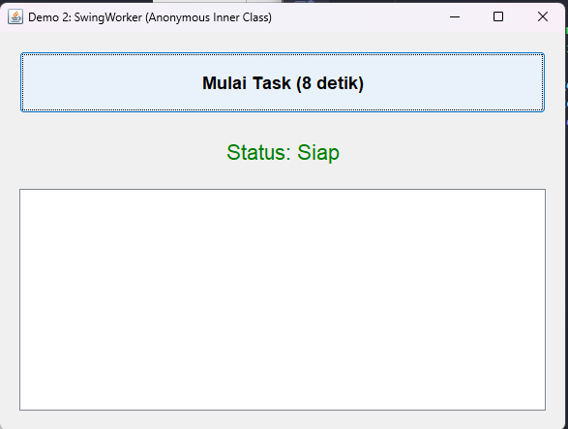

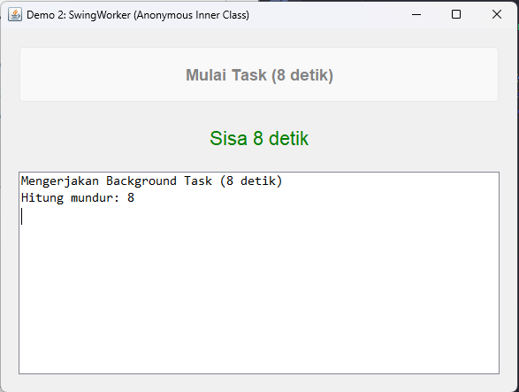

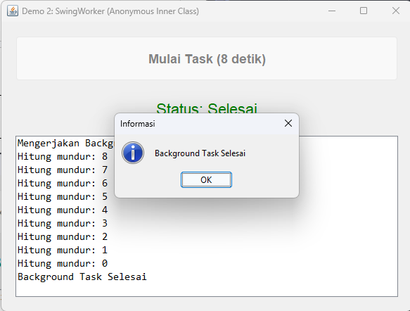

Demo 3
- Kode Program
package Praktikum;
import java.awt.Color;
import java.awt.Dimension;
import java.awt.Font;
import java.util.List;

import javax.swing.JButton;
import javax.swing.JFrame;
import javax.swing.JLabel;
import javax.swing.JOptionPane;
import javax.swing.JPanel;
import javax.swing.JScrollPane;
import javax.swing.JTextArea;
import javax.swing.SwingUtilities;
import javax.swing.SwingWorker;
import javax.swing.UIManager;

import net.miginfocom.swing.MigLayout;

public class Demo3 extends JFrame {

private JPanel panelUtama;
private JButton buttonMulaiTask;
private JLabel labelStatus;
private JTextArea textAreaHasil;

public Demo3() {
initializeUI();
setupEventHandlers();
}

private void initializeUI() {
setTitle("Demo 3: SwingWorker (Static Nested Class)");
setDefaultCloseOperation(JFrame.EXIT_ON_CLOSE);
setPreferredSize(new Dimension(600, 450));

panelUtama = new JPanel(
new MigLayout("fill, wrap 1, insets 20")
);

buttonMulaiTask = new JButton("Mulai Task (8 detik)");
buttonMulaiTask.setFont(new Font("Inter", Font.BOLD, 18));
panelUtama.add(buttonMulaiTask, "growx, h 20%");

labelStatus = new JLabel("Status: Siap", JLabel.CENTER);
labelStatus.setFont(new Font("Inter", Font.PLAIN, 22));
labelStatus.setForeground(new Color(0, 128, 0));
panelUtama.add(labelStatus, "growx, h 20%");

textAreaHasil = new JTextArea();
textAreaHasil.setEditable(false);
textAreaHasil.setFont(new Font("Consolas", Font.PLAIN, 15));
JScrollPane scroll = new JScrollPane(textAreaHasil);
panelUtama.add(scroll, "growx, h 60%");

add(panelUtama);
pack();
setLocationRelativeTo(null);
}

private void setupEventHandlers() {
buttonMulaiTask.addActionListener(
e -> new HitungMundurWorker(this).execute()
);
}

private static class HitungMundurWorker extends SwingWorker<String, Integer> {
private final Demo3 frame;

private HitungMundurWorker(Demo3 frame) {
this.frame = frame;
}

@Override
protected String doInBackground() throws Exception {
frame.buttonMulaiTask.setEnabled(false);
frame.labelStatus.setText("Status: Mulai bekerja");
frame.textAreaHasil.setText("Mengerjakan Background Task (8 detik)\n");

for (int i = 8; i >= 0; i--) {
Thread.sleep(1000);
publish(i);
}
return "Background Task Selesai";
}

@Override
protected void process(List<Integer> chunks) {
int detik = chunks.get(chunks.size() - 1);
frame.textAreaHasil.append("Hitung mundur: " + detik + "\n");
frame.textAreaHasil.setCaretPosition(frame.textAreaHasil.getDocument().getLength());
frame.labelStatus.setText("Sisa " + detik + " detik");
}

@Override
protected void done() {
try {
String hasil = get();
frame.textAreaHasil.append(hasil);
frame.labelStatus.setText("Status: Selesai");
JOptionPane.showMessageDialog(frame, hasil, "Informasi", JOptionPane.INFORMATION_MESSAGE);
} catch (Exception ex) {
frame.labelStatus.setText("Status: Error");
} finally {
frame.buttonMulaiTask.setEnabled(true);
}
}
}

public static void main(String[] args) {
SwingUtilities.invokeLater(() -> {
try {
UIManager.setLookAndFeel(UIManager.getSystemLookAndFeelClassName());
} catch (Exception e) {
System.err.println(e.getMessage());
}
new Demo3().setVisible(true);
});
}
}

- Hasil Run
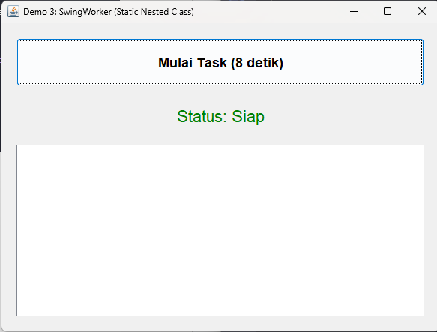

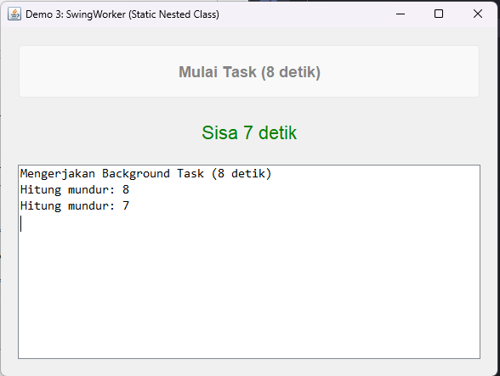

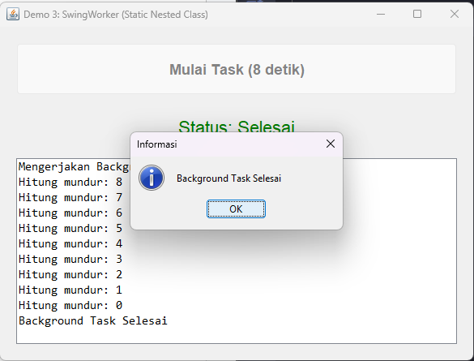

Demo 4
- Kode Program
package Praktikum;
import java.awt.Color;
import java.awt.Dimension;
import java.awt.Font;

import javax.swing.JButton;
import javax.swing.JFrame;
import javax.swing.JLabel;
import javax.swing.JPanel;
import javax.swing.JScrollPane;
import javax.swing.JTextArea;
import javax.swing.SwingUtilities;
import javax.swing.UIManager;

import net.miginfocom.swing.MigLayout;

public class Demo4 extends JFrame {

private JPanel panelUtama;
private JButton buttonMulaiTask;
private JLabel labelStatus;
private JTextArea textAreaHasil;

public Demo4() {
initializeUI();
setupEventHandlers();
}

private void initializeUI() {
setTitle("Demo 4: SwingWorker (Separate Top-Level Class)");
setDefaultCloseOperation(JFrame.EXIT_ON_CLOSE);
setPreferredSize(new Dimension(600, 450));

panelUtama = new JPanel(new MigLayout("fill, wrap 1, insets 20"));

buttonMulaiTask = new JButton("Mulai Task (8 detik)");
buttonMulaiTask.setFont(new Font("Inter", Font.BOLD, 18));
panelUtama.add(buttonMulaiTask, "growx, h 20%");

labelStatus = new JLabel("Status: Siap", JLabel.CENTER);
labelStatus.setFont(new Font("Inter", Font.PLAIN, 22));
labelStatus.setForeground(new Color(0, 128, 0));
panelUtama.add(labelStatus, "growx, h 20%");

textAreaHasil = new JTextArea();
textAreaHasil.setEditable(false);
textAreaHasil.setFont(new Font("Consolas", Font.PLAIN, 15));
JScrollPane scroll = new JScrollPane(textAreaHasil);
panelUtama.add(scroll, "growx, h 60%");

add(panelUtama);
pack();
setLocationRelativeTo(null);
}

private void setupEventHandlers() {
buttonMulaiTask.addActionListener(e -> {
buttonMulaiTask.setEnabled(false);
new HitungMundurWorker(this, labelStatus, textAreaHasil, buttonMulaiTask).execute();
});
}

public static void main(String[] args) {
SwingUtilities.invokeLater(() -> {
try {
UIManager.setLookAndFeel(UIManager.getSystemLookAndFeelClassName());
} catch (Exception e) {
System.err.println(e.getMessage());
}
new Demo4().setVisible(true);
});
}
}

- Hasil Run
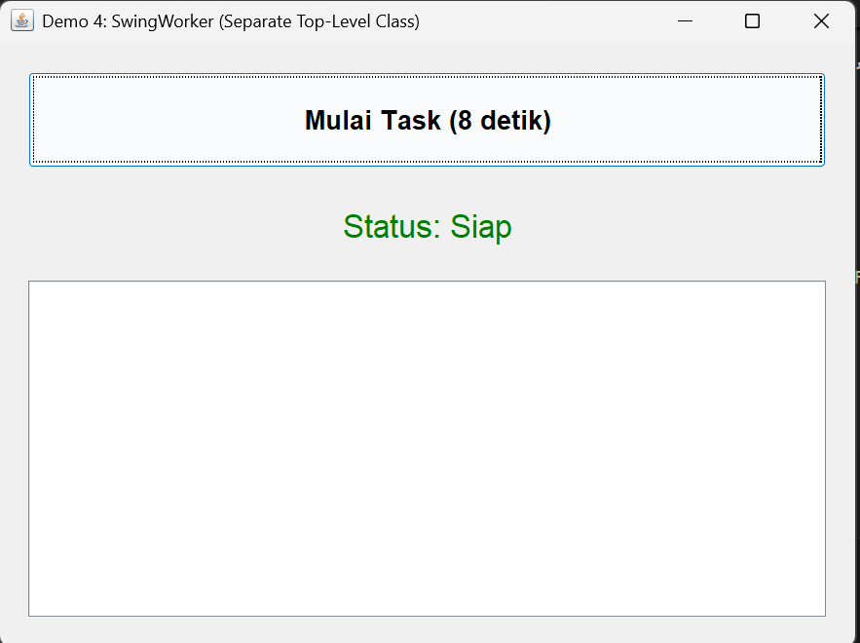

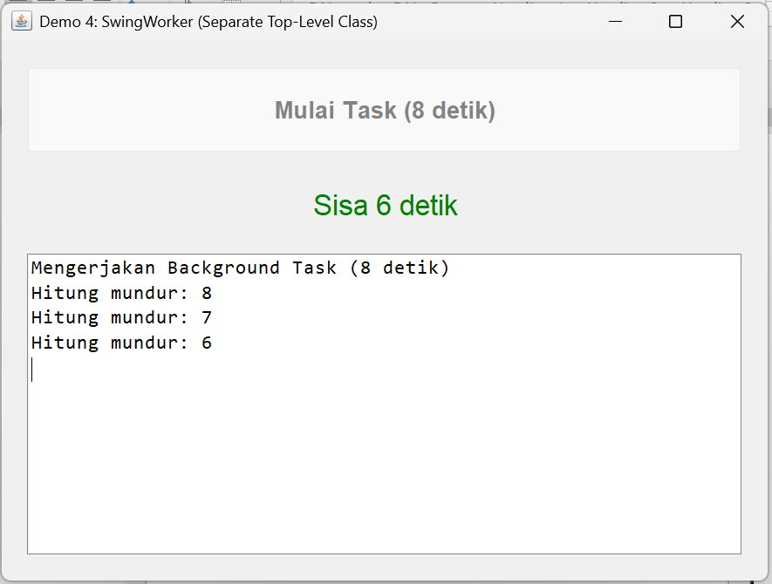
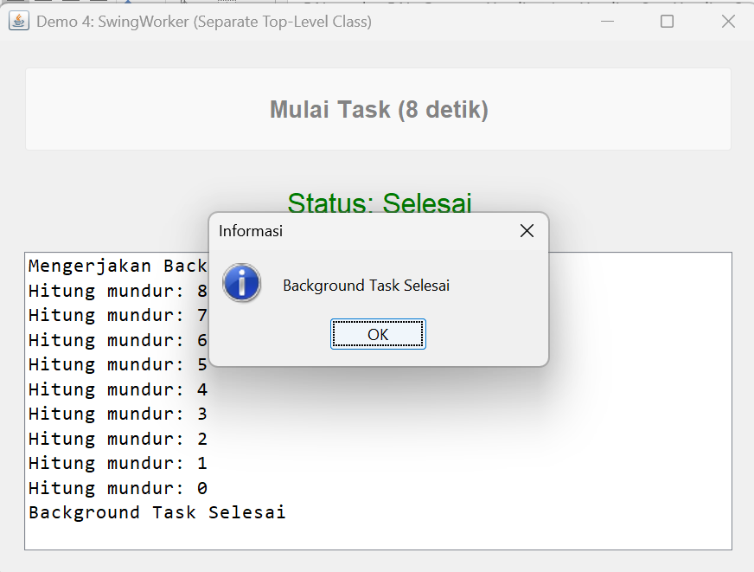

Hitung Mundur Worker
- Kode Program
package Praktikum;
import java.util.List;

import javax.swing.JButton;
import javax.swing.JFrame;
import javax.swing.JLabel;
import javax.swing.JOptionPane;
import javax.swing.JTextArea;
import javax.swing.SwingWorker;

public class HitungMundurWorker extends SwingWorker<String, Integer> {
private final JFrame frame;
private final JLabel labelStatus;
private final JTextArea textAreaHasil;
private final JButton buttonMulaiTask;

public HitungMundurWorker(JFrame frame, JLabel labelStatus, JTextArea textAreaHasil, JButton buttonMulaiTask) {
this.frame = frame;
this.labelStatus = labelStatus;
this.textAreaHasil = textAreaHasil;
this.buttonMulaiTask = buttonMulaiTask;
}

@Override
protected String doInBackground() throws Exception {
buttonMulaiTask.setEnabled(false);
labelStatus.setText("Status: Mulai bekerja");
textAreaHasil.setText("Mengerjakan Background Task (8 detik)\n");

for (int i = 8; i >= 0; i--) {
Thread.sleep(1000);
publish(i);
}
return "Background Task Selesai";
}

@Override
protected void process(List<Integer> chunks) {
int detik = chunks.get(chunks.size() - 1);
textAreaHasil.append("Hitung mundur: " + detik + "\n");
textAreaHasil.setCaretPosition(textAreaHasil.getDocument().getLength());
labelStatus.setText("Sisa " + detik + " detik");
}

@Override
protected void done() {
try {
String hasil = get();
textAreaHasil.append(hasil);
labelStatus.setText("Status: Selesai");
JOptionPane.showMessageDialog(frame, hasil, "Informasi", JOptionPane.INFORMATION_MESSAGE);
} catch (Exception ex) {
labelStatus.setText("Status: Error");
} finally {
buttonMulaiTask.setEnabled(true);
}
}

}

Demo 5
- Kode Program
package Praktikum;
import java.awt.Color;
import java.awt.Dimension;
import java.awt.Font;
import java.util.List;
import java.util.concurrent.CancellationException;
import java.util.concurrent.ExecutionException;

import javax.swing.JButton;
import javax.swing.JFrame;
import javax.swing.JLabel;
import javax.swing.JOptionPane;
import javax.swing.JPanel;
import javax.swing.JProgressBar;
import javax.swing.JScrollPane;
import javax.swing.JTextArea;
import javax.swing.SwingUtilities;
import javax.swing.SwingWorker;
import javax.swing.UIManager;

import net.miginfocom.swing.MigLayout;

public class Demo5 extends JFrame {

private JPanel panelUtama;
private JButton buttonMulaiTask;
private JButton buttonCancel;
private JLabel labelStatus;
private JProgressBar progressBar;
private JTextArea textAreaHasil;
private SwingWorker<Integer, Integer> worker;

public Demo5() {
initializeUI();
setupEventHandlers();
}

private void initializeUI() {
setTitle("Demo 5: SwingWorker + Cancelation");
setDefaultCloseOperation(JFrame.EXIT_ON_CLOSE);
setPreferredSize(new Dimension(720, 520));

panelUtama = new JPanel(
new MigLayout("fill, wrap 1, insets 20")
);
addPanelTombol();
addLabelStatus();
addProgressBar();
addScrollTextArea();

add(panelUtama);
pack();
setLocationRelativeTo(null);
}

private void addPanelTombol() {
JPanel panelTombol = new JPanel(
new MigLayout("fill", "[grow][grow]")
);
buttonMulaiTask = new JButton("Mulai Task (8 detik)");
buttonCancel = new JButton("Cancel");
buttonMulaiTask.setFont(new Font("Inter", Font.BOLD, 18));
buttonCancel.setFont(new Font("Inter", Font.BOLD, 18));
buttonCancel.setEnabled(false);
panelTombol.add(buttonMulaiTask, "w 90%, growy");
panelTombol.add(buttonCancel, "w 10%, growy");
panelUtama.add(panelTombol, "h 20%, hmin pref, grow");
}

private void addLabelStatus() {
labelStatus = new JLabel("Status: Siap", JLabel.CENTER);
labelStatus.setFont(new Font("Inter", Font.BOLD, 24));
labelStatus.setForeground(new Color(0, 100, 0));
panelUtama.add(labelStatus, "h 10%, hmin pref, growx");
}

private void addProgressBar() {
progressBar = new JProgressBar(0, 100);
progressBar.setStringPainted(true);
progressBar.setFont(new Font("Inter", Font.BOLD, 18));
progressBar.setValue(0);
panelUtama.add(progressBar, "h 10%, hmin pref, growx");
}

private void addScrollTextArea() {
textAreaHasil = new JTextArea();
textAreaHasil.setEditable(false);
textAreaHasil.setFont(new Font("Consolas", Font.PLAIN, 14));
JScrollPane scroll = new JScrollPane(textAreaHasil);
panelUtama.add(scroll, "h 60%, growx");
}

private void setupEventHandlers() {
buttonMulaiTask.addActionListener(e -> mulaiProses());
buttonCancel.addActionListener(e -> {
if (worker != null && !worker.isDone()) {
worker.cancel(true);
addLog("Proses dibatalkan oleh user...");
buttonCancel.setEnabled(false);
buttonMulaiTask.setEnabled(true);
}
});
}

private void mulaiProses() {
buttonMulaiTask.setEnabled(false);
buttonCancel.setEnabled(true);
progressBar.setValue(0);
textAreaHasil.setText("");
labelStatus.setText("Status: Mulai bekerja");
addLog("Mengerjakan Background Task (8 detik)");

worker = new SwingWorker<Integer, Integer>() {
@Override
protected Integer doInBackground() throws Exception {
int total = 100;
for (int i = 1; i <= total; i++) {
if (isCancelled()) return null;
Thread.sleep(80);
publish(i);
}
return total;
}

@Override
protected void process(List<Integer> chunks) {
if (isCancelled()) return;
int progress = chunks.get(chunks.size() - 1);
progressBar.setValue(progress);
int remainingSeconds = 8 - (8 * progress / 100);
labelStatus.setText("Sisa " + remainingSeconds + " detik");
addLog("Persentase pengerjaan task: " + progress + "%");
}

@Override
protected void done() {
try {
Integer result = get();
labelStatus.setText("Status: Selesai");
addLog("Background Task Selesai " + result + "%");
JOptionPane.showMessageDialog(Demo5.this,
"Background Task Selesai",
"Informasi", JOptionPane.INFORMATION_MESSAGE);
} catch (ExecutionException ex) {
labelStatus.setText("Status: Error");
addLog("Error: " + ex.getCause().getMessage());
JOptionPane.showMessageDialog(Demo5.this,
"Terjadi kesalahan: " + ex.getMessage(),
"Error", JOptionPane.ERROR_MESSAGE);
} catch (CancellationException ee){
labelStatus.setText("Status: Dibatalkan");
} catch (InterruptedException e) {
Thread.currentThread().interrupt();
} finally {
buttonCancel.setEnabled(false);
buttonMulaiTask.setEnabled(true);
worker = null;
}
}
};

worker.execute();
}

private void addLog(String text) {
textAreaHasil.append(text + "\n");
textAreaHasil.setCaretPosition(textAreaHasil.getDocument().getLength());
}

public static void main(String[] args) {
SwingUtilities.invokeLater(() -> {
try {
UIManager.setLookAndFeel(UIManager.getSystemLookAndFeelClassName());
} catch (Exception ignored) {}
new Demo5().setVisible(true);
});
}
}

- Hasil Run
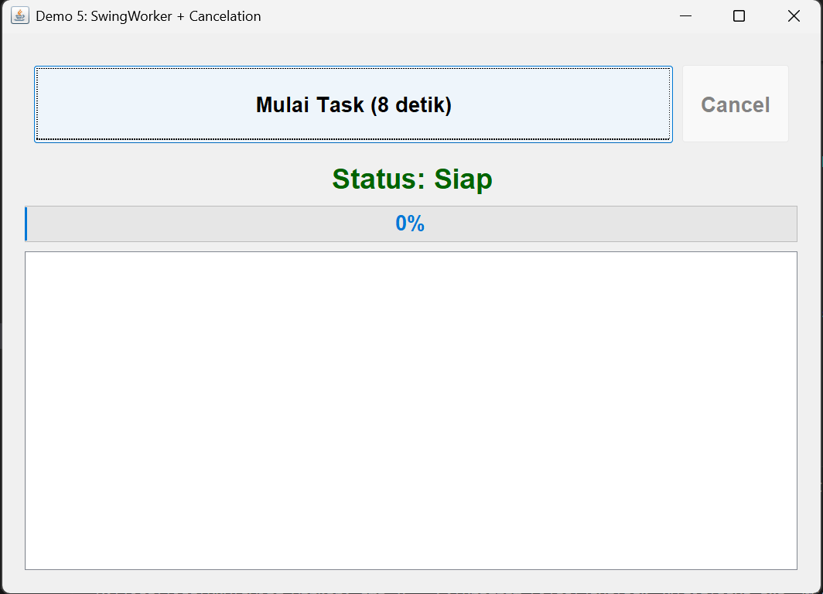

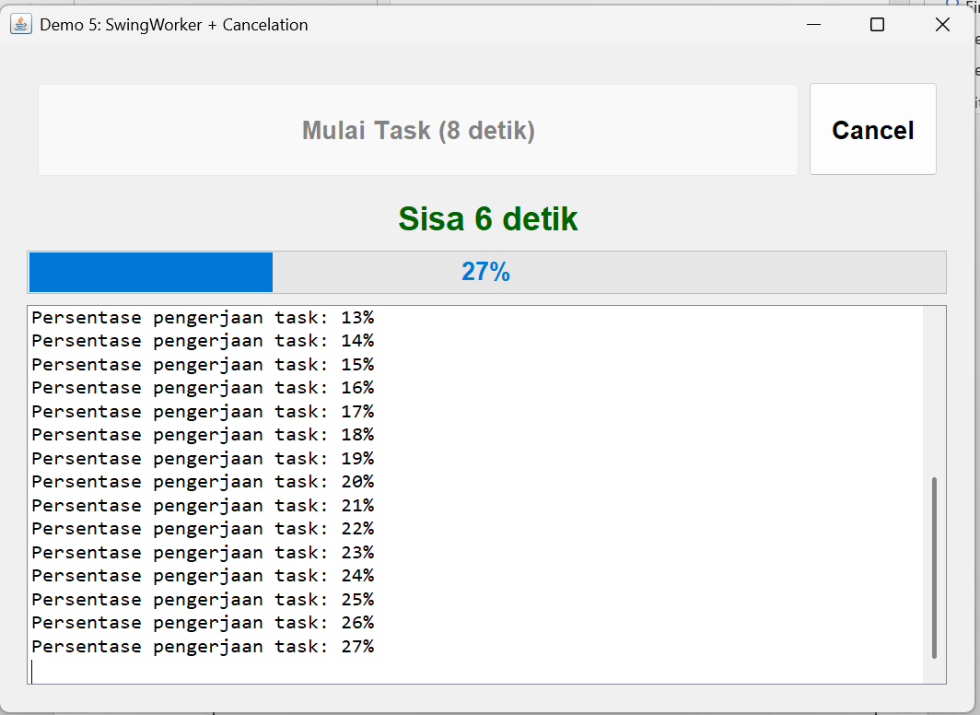

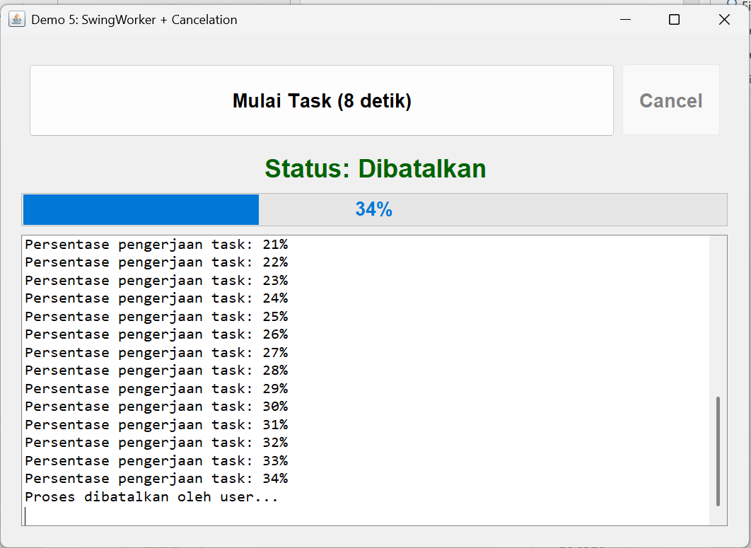

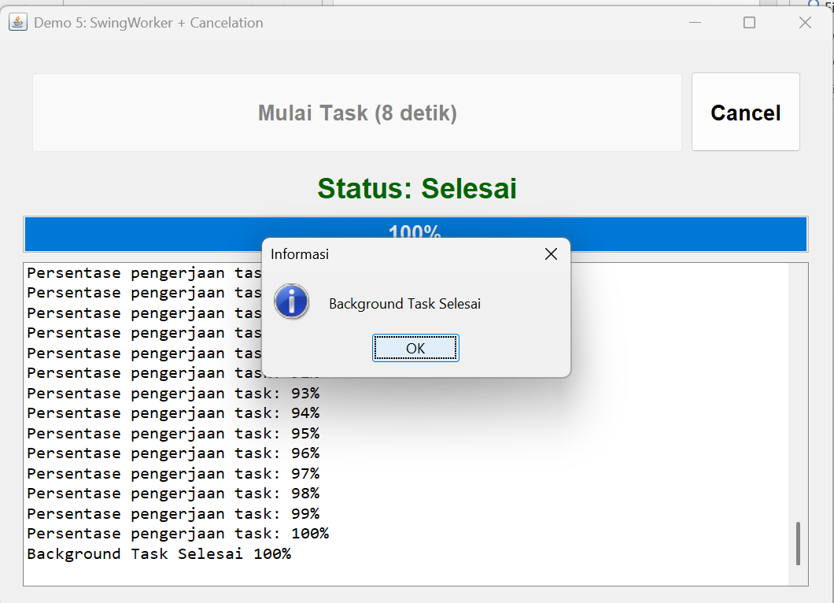

LATIHAN

Task Worker
- Kode Program
package Latihan;

import java.util.List;
import java.util.concurrent.CancellationException;
import java.util.concurrent.ExecutionException;

import javax.swing.SwingWorker;

public class TaskWorker extends SwingWorker<Integer, Integer> {

public interface Listener {
void onProgressUpdate(int progress, int remainingSeconds);
void onLog(String msg);
void onCompleted(int result);
void onCancelled();
void onError(Exception ex);
}

private final Listener listener;

public TaskWorker(Listener listener) {
this.listener = listener;
}

@Override
protected Integer doInBackground() throws Exception {
int total = 100;
for (int i = 1; i <= total; i++) {
if (isCancelled()) return null;

Thread.sleep(80);
publish(i);
}
return total;
}

@Override
protected void process(List<Integer> chunks) {
if (isCancelled()) return;

int progress = chunks.get(chunks.size() - 1);
int remainingSeconds = 8 - (8 * progress / 100);

listener.onProgressUpdate(progress, remainingSeconds);
listener.onLog("Persentase pengerjaan task: " + progress + "%");
}

@Override
protected void done() {
try {
Integer result = get();
listener.onCompleted(result);
} catch (CancellationException e) {
listener.onCancelled();

} catch (ExecutionException e) {
listener.onError(e);

} catch (InterruptedException e) {
Thread.currentThread().interrupt();
}
}
}

Demo 6
- Kode Program
package Latihan;

import java.awt.Color;
import java.awt.Dimension;
import java.awt.Font;

import javax.swing.JButton;
import javax.swing.JFrame;
import javax.swing.JLabel;
import javax.swing.JOptionPane;
import javax.swing.JPanel;
import javax.swing.JProgressBar;
import javax.swing.JScrollPane;
import javax.swing.JTextArea;
import javax.swing.SwingUtilities;
import javax.swing.UIManager;

import net.miginfocom.swing.MigLayout;

public class Demo6 extends JFrame implements TaskWorker.Listener {

private JPanel panelUtama;
private JButton buttonMulaiTask;
private JButton buttonCancel;
private JLabel labelStatus;
private JProgressBar progressBar;
private JTextArea textAreaHasil;

private TaskWorker worker;

public Demo6() {
initializeUI();
setupEventHandlers();
}

private void initializeUI() {
setTitle("Demo 6: SwingWorker Toplevel + Cancelation");
setDefaultCloseOperation(JFrame.EXIT_ON_CLOSE);
setPreferredSize(new Dimension(720, 520));

panelUtama = new JPanel(new MigLayout("fill, wrap 1, insets 20"));

addPanelTombol();
addLabelStatus();
addProgressBar();
addScrollTextArea();

add(panelUtama);
pack();
setLocationRelativeTo(null);
}

private void addPanelTombol() {
JPanel panelTombol = new JPanel(new MigLayout("fill", "[grow][grow]"));
buttonMulaiTask = new JButton("Mulai Task (8 detik)");
buttonCancel = new JButton("Cancel");

buttonMulaiTask.setFont(new Font("Inter", Font.BOLD, 18));
buttonCancel.setFont(new Font("Inter", Font.BOLD, 18));
buttonCancel.setEnabled(false);

panelTombol.add(buttonMulaiTask, "w 90%, growy");
panelTombol.add(buttonCancel, "w 10%, growy");

panelUtama.add(panelTombol, "h 20%, grow");
}

private void addLabelStatus() {
labelStatus = new JLabel("Status: Siap", JLabel.CENTER);
labelStatus.setFont(new Font("Inter", Font.BOLD, 24));
labelStatus.setForeground(new Color(0, 100, 0));
panelUtama.add(labelStatus, "h 10%, growx");
}

private void addProgressBar() {
progressBar = new JProgressBar(0, 100);
progressBar.setStringPainted(true);
progressBar.setFont(new Font("Inter", Font.BOLD, 18));
panelUtama.add(progressBar, "h 10%, growx");
}

private void addScrollTextArea() {
textAreaHasil = new JTextArea();
textAreaHasil.setEditable(false);
textAreaHasil.setFont(new Font("Consolas", Font.PLAIN, 14));
JScrollPane scroll = new JScrollPane(textAreaHasil);

panelUtama.add(scroll, "h 60%, grow");
}

private void setupEventHandlers() {

buttonMulaiTask.addActionListener(e -> mulaiProses());

buttonCancel.addActionListener(e -> {
if (worker != null && !worker.isDone()) {
worker.cancel(true);
addLog("Proses dibatalkan oleh user...");
}
});
}

private void mulaiProses() {
buttonMulaiTask.setEnabled(false);
buttonCancel.setEnabled(true);
progressBar.setValue(0);
textAreaHasil.setText("");

labelStatus.setText("Status: Mulai bekerja");
addLog("Mengerjakan Background Task (8 detik)");

worker = new TaskWorker(this);
worker.execute();
}

private void addLog(String msg) {
textAreaHasil.append(msg + "\n");
textAreaHasil.setCaretPosition(textAreaHasil.getDocument().getLength());
}

@Override
public void onProgressUpdate(int progress, int remainingSeconds) {
progressBar.setValue(progress);
labelStatus.setText("Sisa " + remainingSeconds + " detik");
}

@Override
public void onLog(String msg) {
addLog(msg);
}

@Override
public void onCompleted(int result) {
labelStatus.setText("Status: Selesai");
addLog("Background Task Selesai " + result + "%");

JOptionPane.showMessageDialog(this,
"Background Task Selesai",
"Informasi",
JOptionPane.INFORMATION_MESSAGE);

resetButtons();
}

@Override
public void onCancelled() {
labelStatus.setText("Status: Dibatalkan");
addLog("Task dibatalkan.");
resetButtons();
}

@Override
public void onError(Exception ex) {
labelStatus.setText("Status: Error");
addLog("Error: " + ex.getMessage());

JOptionPane.showMessageDialog(this,
"Terjadi kesalahan: " + ex.getMessage(),
"Error",
JOptionPane.ERROR_MESSAGE);

resetButtons();
}

private void resetButtons() {
buttonMulaiTask.setEnabled(true);
buttonCancel.setEnabled(false);
worker = null;
}

public static void main(String[] args) {
SwingUtilities.invokeLater(() -> {
try {
UIManager.setLookAndFeel(UIManager.getSystemLookAndFeelClassName());
} catch (Exception ignored) {}
new Demo6().setVisible(true);
});
}
}

- Hasil Run
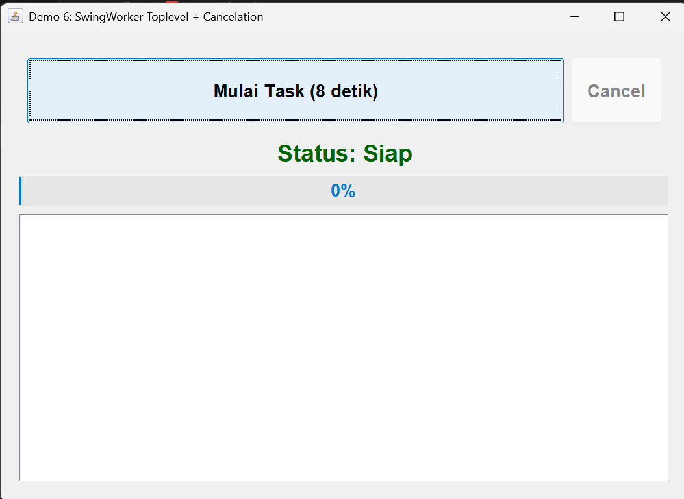

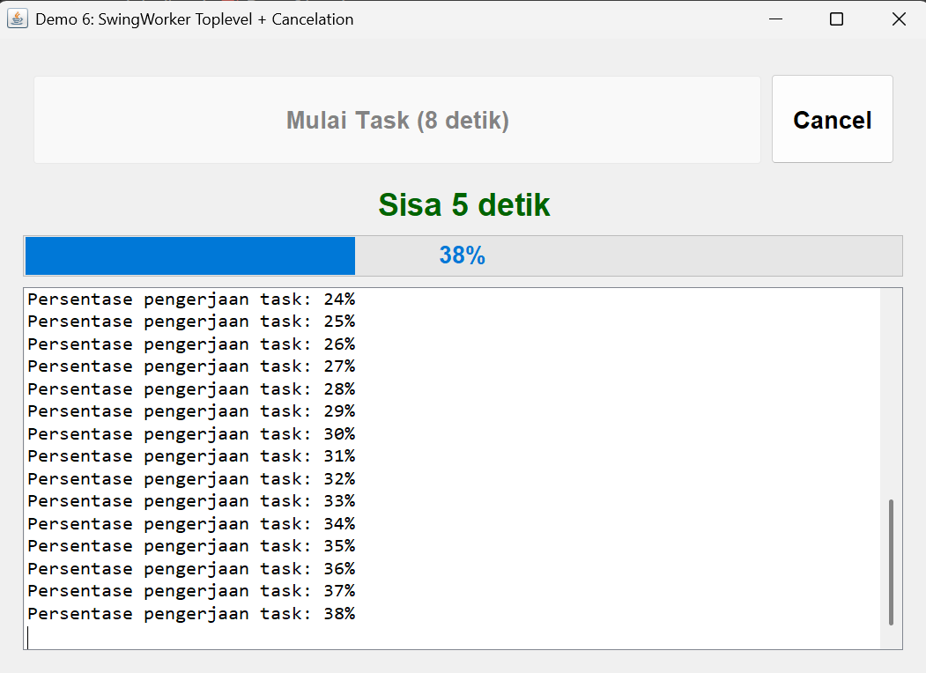

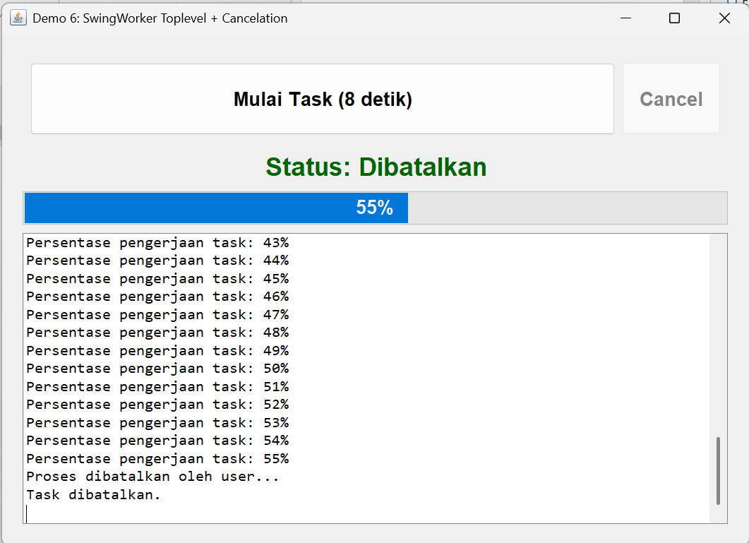

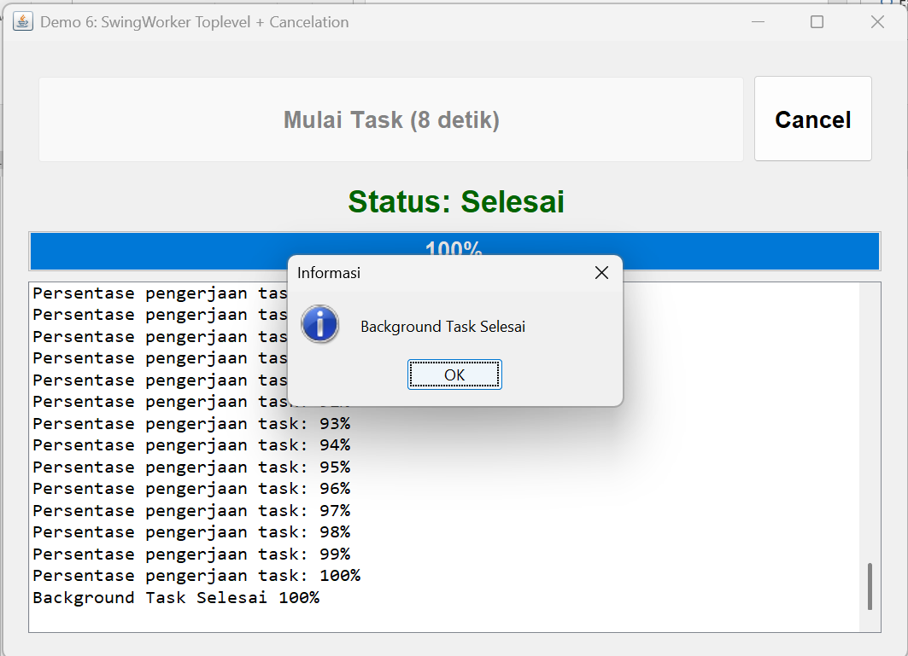

PENGALAMAN PEMBELAJARAN
Pada pengalaman pembelajaran kali ini, kita belajar bagaimana suatu perangkat melakukan operasi yang berat dapat membuat freeze, namun segala sesuatu nya pasti ada jalan keluar nya. Kemudian mempelajari Concurrency yang mana dapat melakukan eksekusi secara bersamaan.
Dalam pengerjaan praktikum agak sedikit bingung, pada bagian Demo2 – Demo4, dikarenakan hasil Outputnya hamper tidak ada bedannya. Sehingga pada pengerjaan tugas pun, Output dari Demo5 dan Demo6 (Latihan) hampir sama.

